**AWS Advanced Projects (Day3-Day4)**

**========================================**

**Project 1:** Deploying a web server in Windows instance

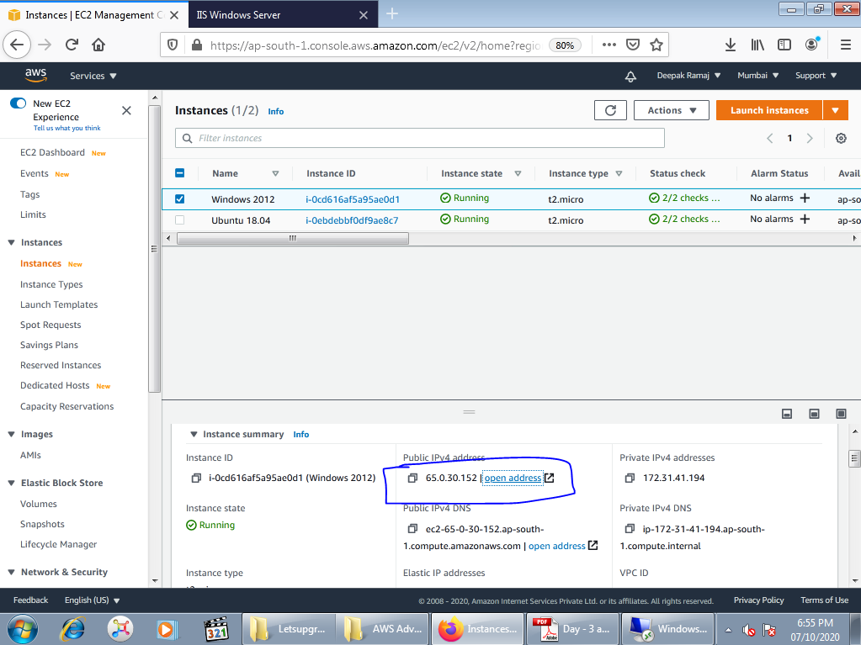

Fig 1.1 Windows instance

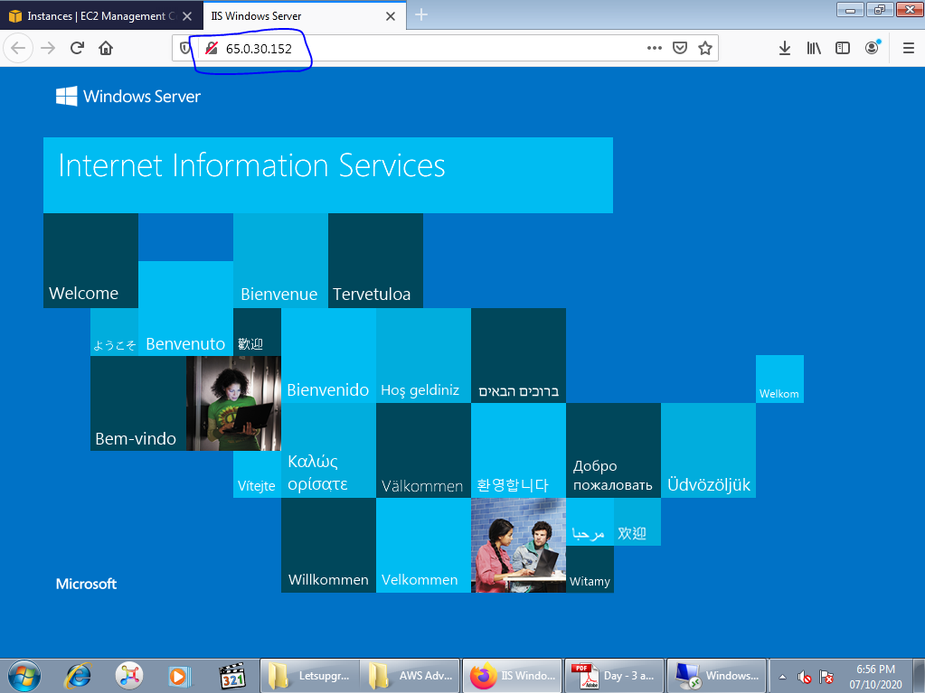

Fig 1.2 IIS Web server

**Project 2:** Deploying a Nginx web server in Ubuntu instance

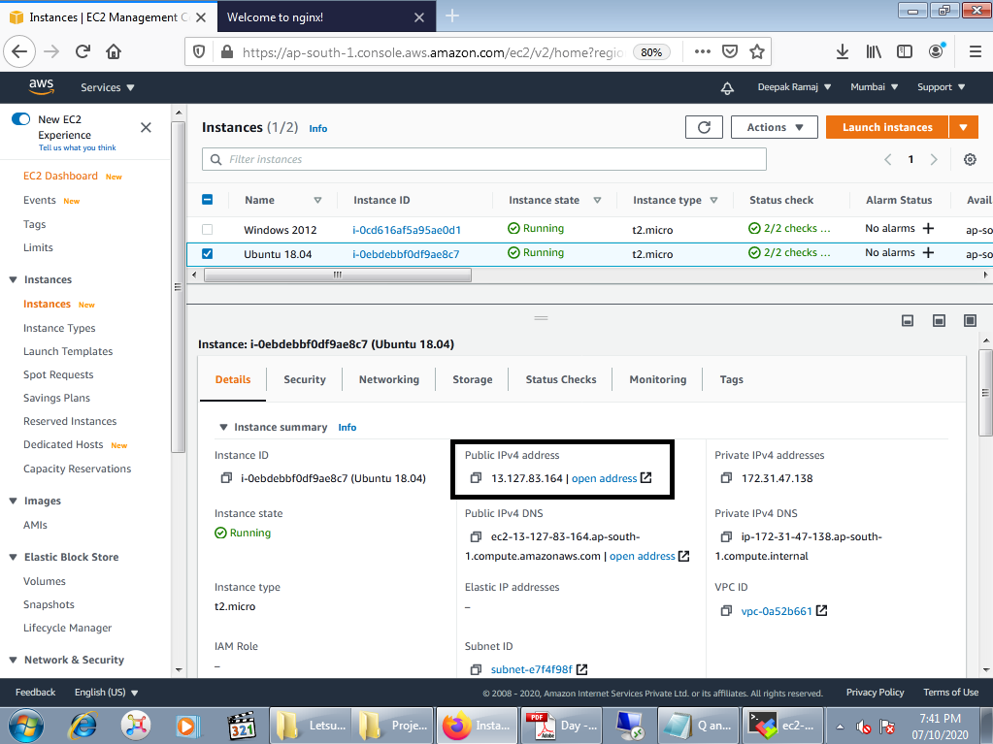

Fig 2.1 Ubuntu instance

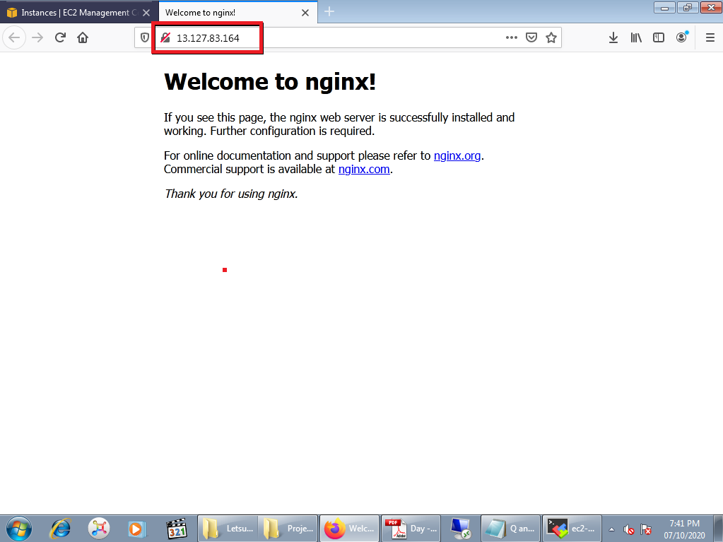

Fig 2.2 Nginx web server

**Project 3:** Workingwith EBS volumes

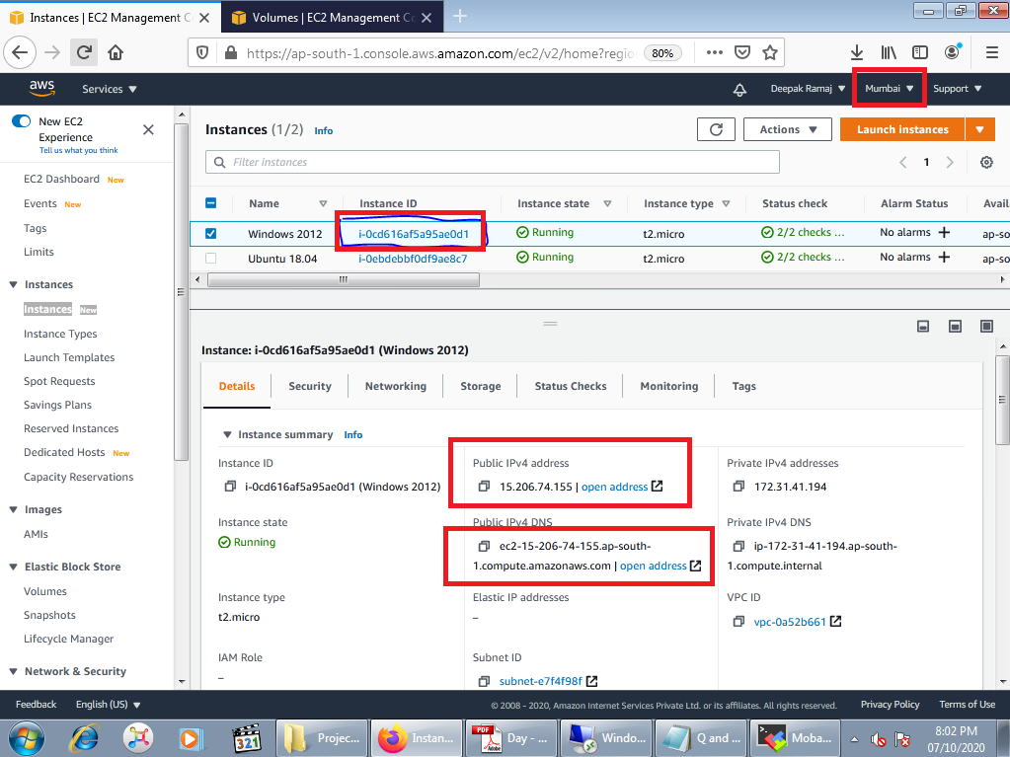

Fig 3.1 Windows Instance

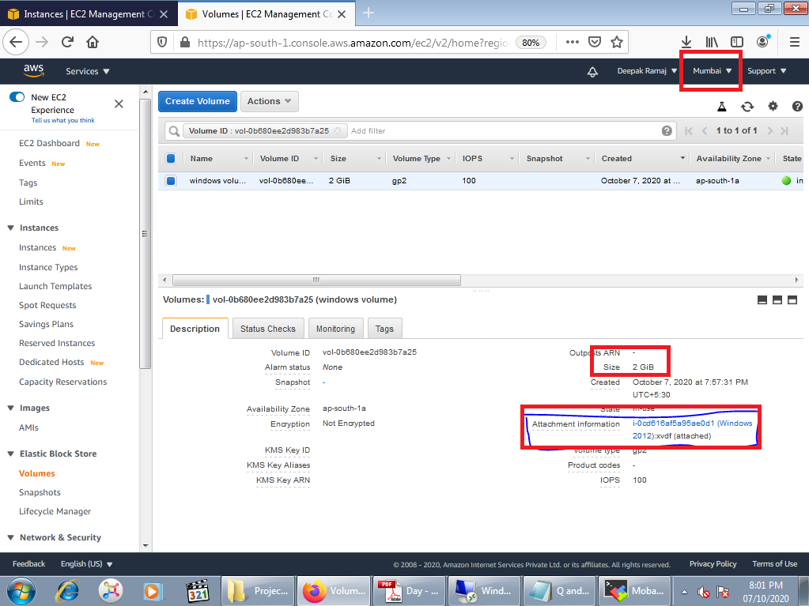

Fig 3.2 Volume creation and attachment

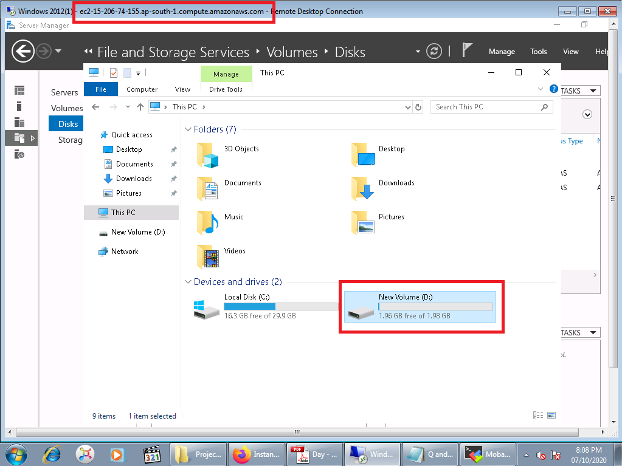

Fig 3.3 Volume attached and mounted successfully

**Project 4:** Working with Elastic IP's

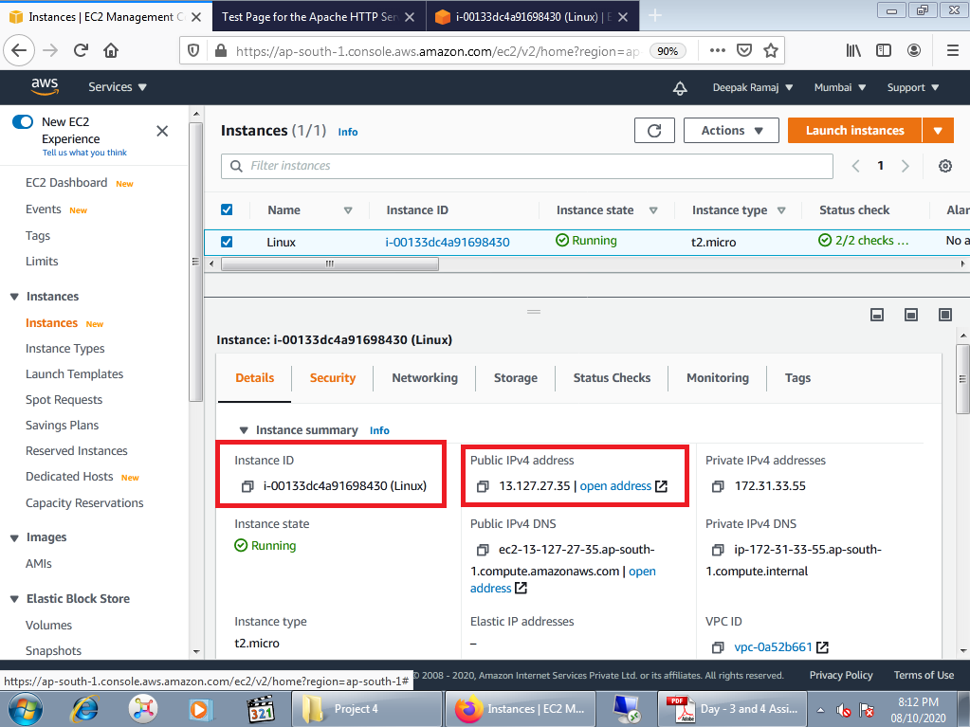

Fig 4.1 Linux instance

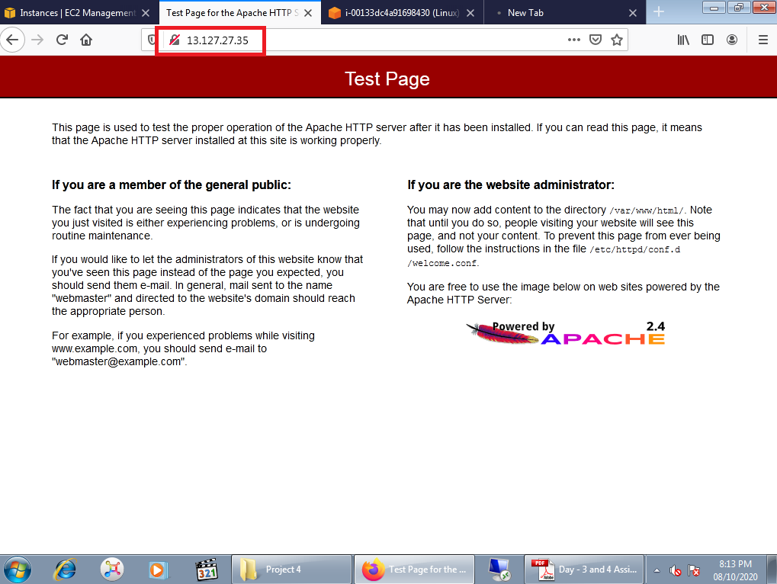

Fig 4.2 Apache server Test Page using public IP

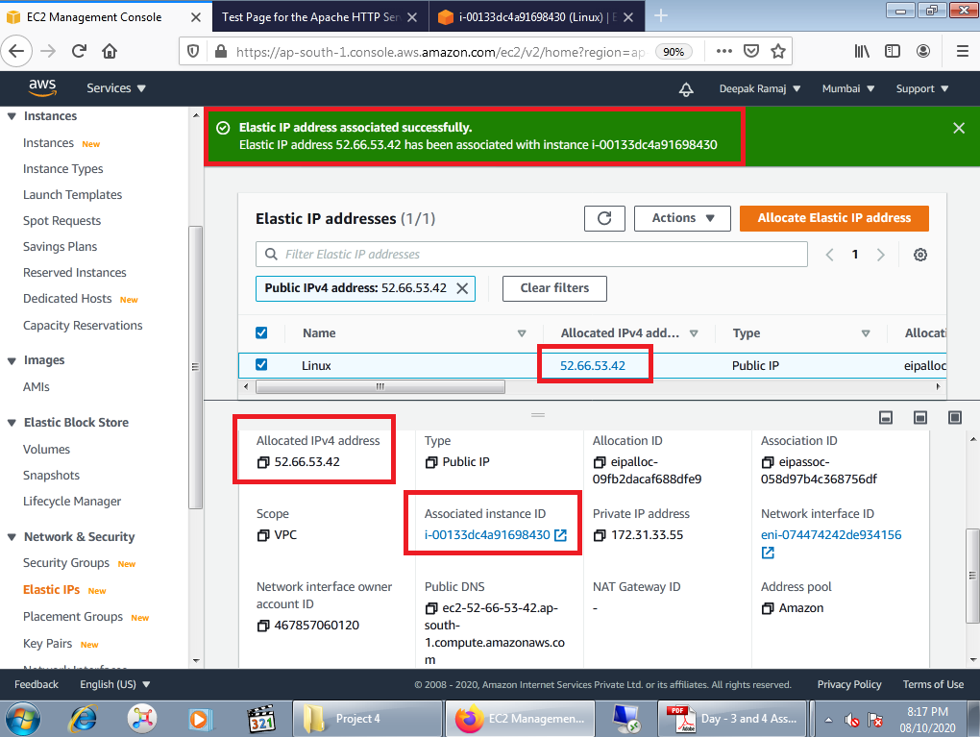

Fig 4.3 Elastic IP creation and associated with Linux instance

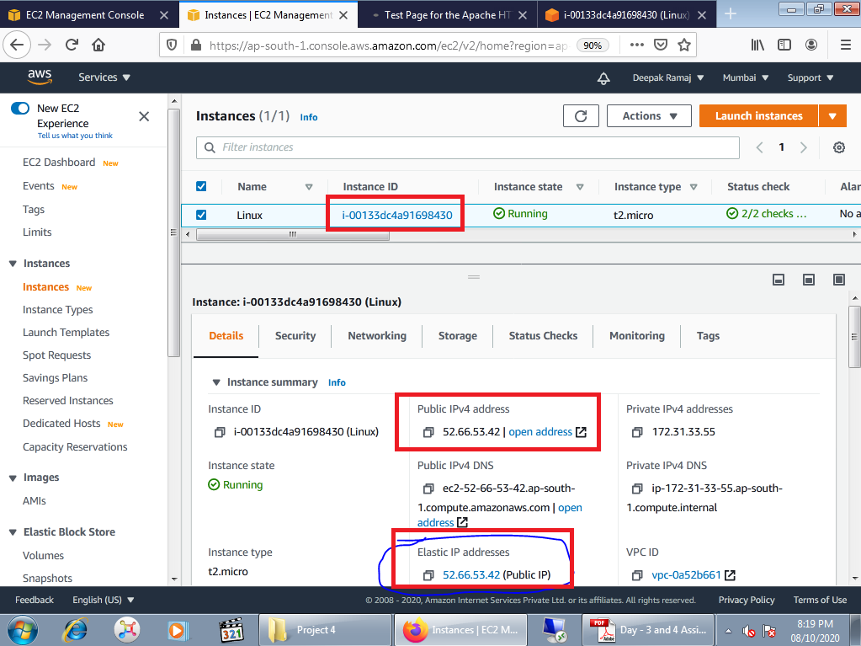

Fig 4.4 Associated elastic IP

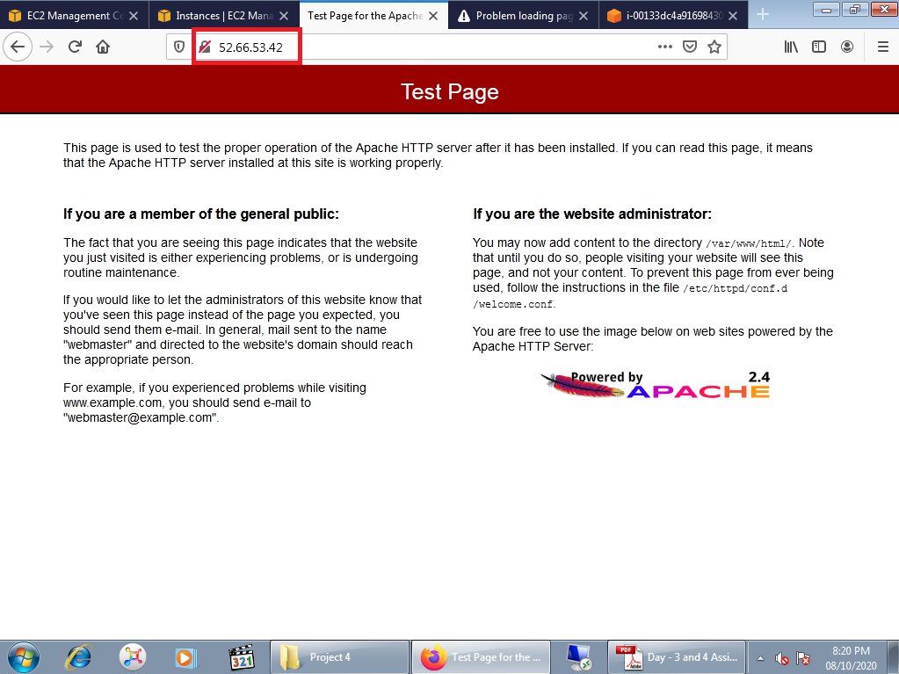

Fig 4.5 Launched Apache server using Elastic IP

**Project 5:** Working with S3

A. working with S3-.jpg

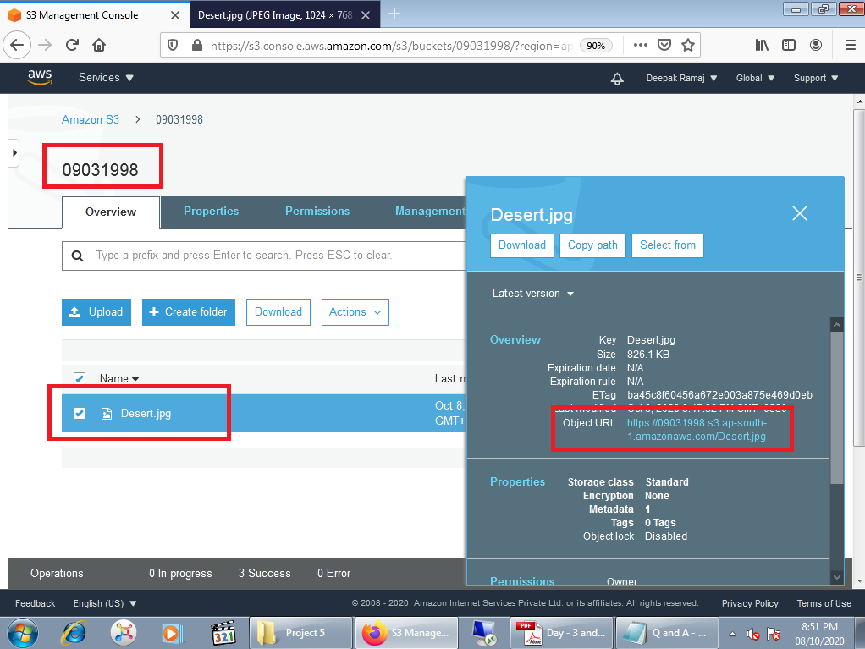

Fig. 5.1 Created S3 bucket and uploaded .jpg file

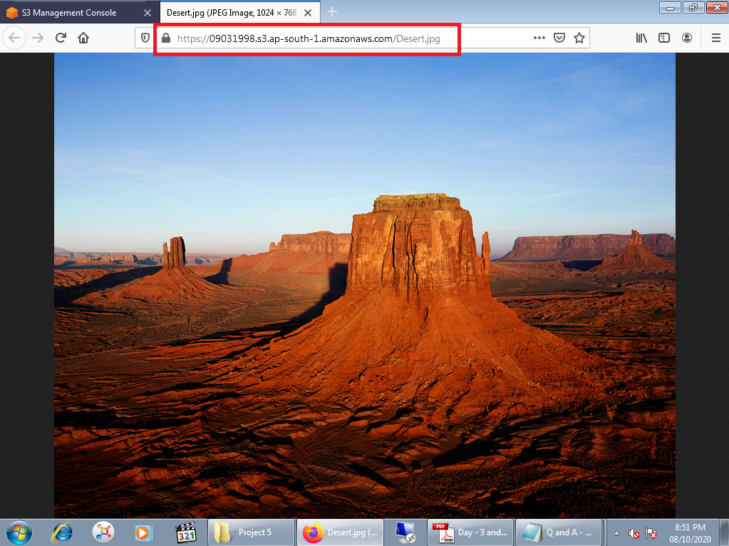

Fig 5.2 Launched and opened uploaded file using object URL

B. Static web hosting

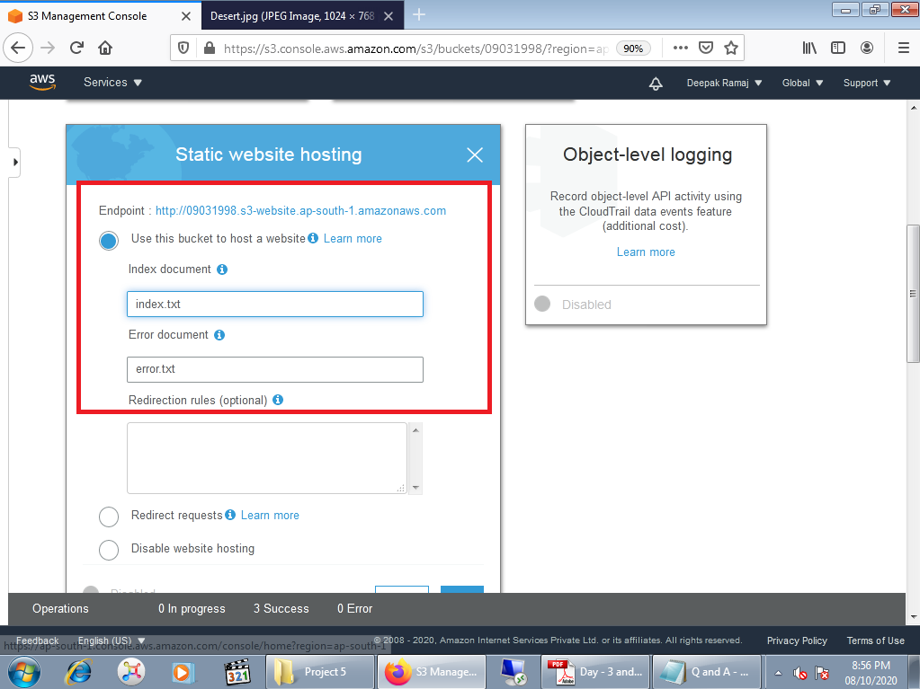

Fig 5.3 Static web hosting

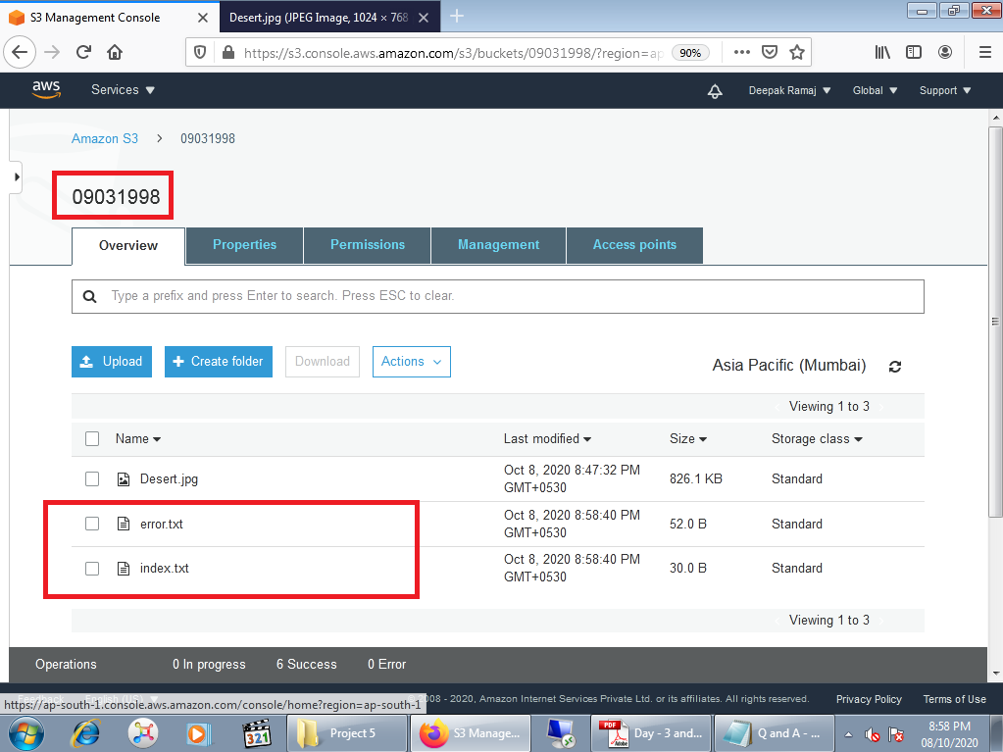

Fig 5.4 Uploaded index.txt and error.txt file in bucket

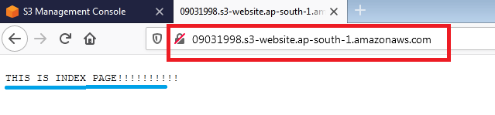

Fig 5.5 Launched index.txt file using endpoint URL

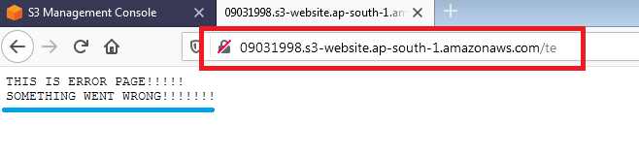

Fig 5.6 Launched error.txt file by making changes in endpoint URL

C. Versioning:

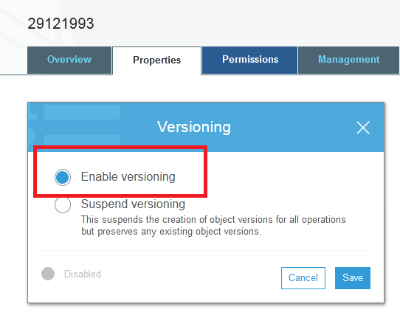

Fig 5.7 Enabling versioning

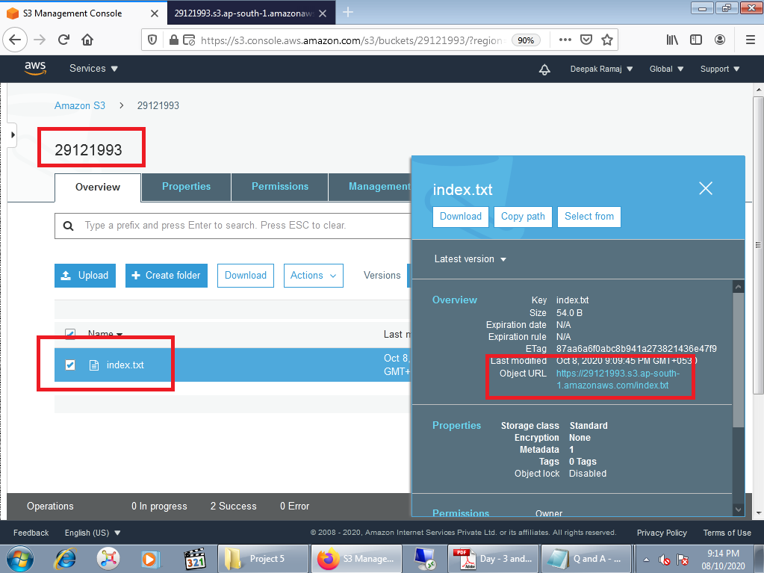

Fig 5.8 Uploaded index.txt file in bucket

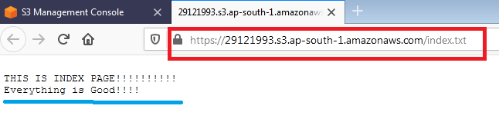

Fig 5.9 Launching index.txt file

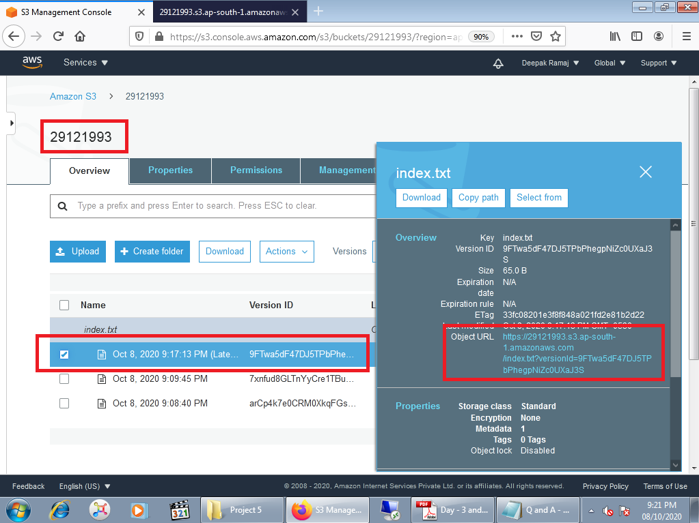

Fig 5.10 showing the versions of uploaded file

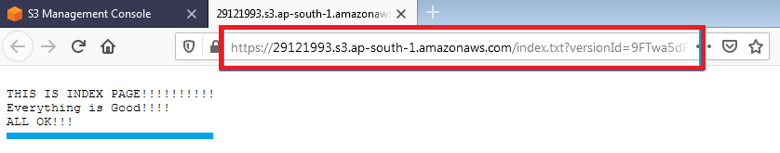

Fig 5.11 launched the latest version of file

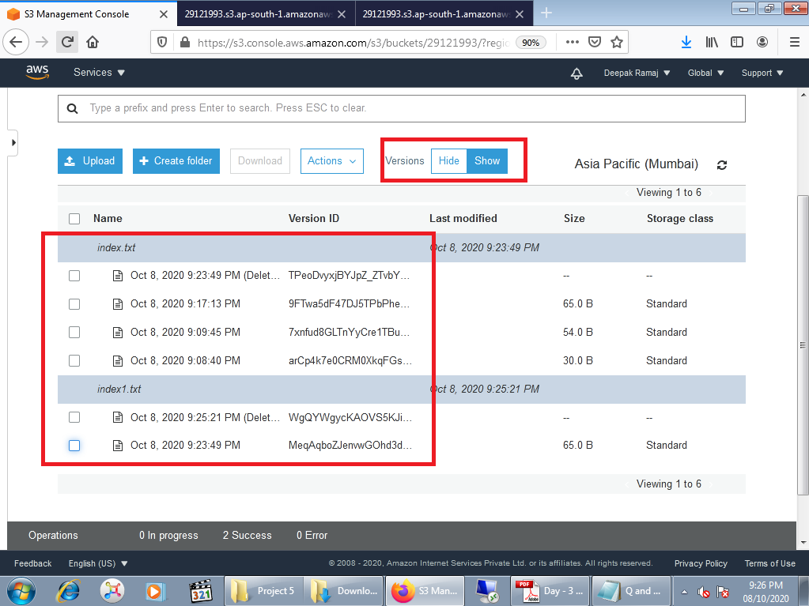

Fig 5.12 Different versions of file

**QUESTION 1:**

Explain life cycle effects on instances: Stop, start, reboot, terminate-public IP, Private IP, and Applications installed.

Answer:

Scenario 1- Reboot instance

After **rebooting** the instance **public IP** and **private IP** will **not change** and also **able** to **launch the applications** installed on server from same public IP.

Scenario 2- Stop and Start instance

After **stop and start** the instance the **public IP** is getting **changed** but the **private IP** will **not change**. The **applications** installed are only **accessible** from changed public IP.

Scenario 3- terminating the instance

After **terminating** the instance the public IP, private IP and applications installed on server will no longer able to access.

In short:

1. Rebooting instance:

Private IP - Will not change

Public IP- Will not change

Applications installed – Are accessible from public IP

1. Stop-Start instance:

Private IP - Will not change

Public IP- Will change

Applications installed - Are accessible only from changed public IP (new IP after restart).

1. Terminate instance: ( Instance will be deleted permanently)

Private IP – Not able to access

Public IP- Not able to access

Applications installed - Not able to access